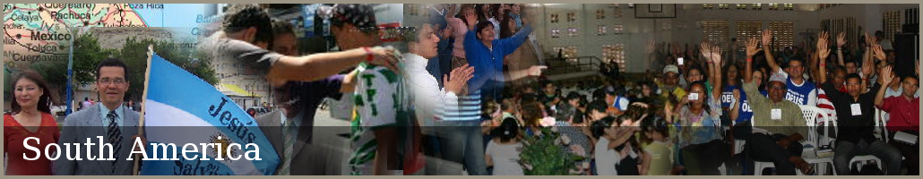
Fact Sheet for The Elijah Challenge

The Elijah Challenge uses scripture only to equip believers according to John 14:11-12 to minister healing to the sick as Jesus taught His disciples. The miracles are evidence to the world that Jesus is the only way to the Father. It is instrumental in equipping the Church to fulfill the Great Commission to those who never heard, and also preparing God's backslidden people for the return of the Lord Jesus Christ by confirming the preaching of repentance. It has been accepted by evangelical Southern Baptist leaders who have attended the Training. The time of the superstar "one-man-show" evangelist is fading and the time of the nameless disciple is at hand.

We do not teach the “gift of healing” (1 Corinthians 12) which not all believers have. Rather we teach disciples from Scripture how to minister healing using the authority to heal which has been given to every witness of Jesus Christ (Luke 9:1-2; 10:1,9). There are clear differences between the gift of healing and the authority to heal.

Outline of Training
- The authority to heal in the gospels
  - How Jesus healed the infirm using authority
  - Why do we usually fail when using authority to heal the sick?
- The authority to heal in Acts after the Day of Pentecost when the gift of healing was available
- The Biblical basis for the laying on of hands
- Ministering healing at a distance (Luke 7)
- Ministering healing to believers according to James 5:14-16

Testimonials from alumni of The Elijah Challenge

Evangelist Emmanuel Abdullahi of Nigeria attended the Training in November 2004
"I am very happy to identify with you; I feel good doing the work of God with the proof [of miracles]. The result---what I have not seen for the past 16 years I have seen it in less than a year. What you taught me I have communicated the same revelation to hundreds of ministers and believers. I am currently in high demand by churches. I give glory to God."

"You have imparted much into me, and countless other [servants of the Lord] have benefited with an outstanding healing testimony in their ministries. The same thing you taught me I have communicated to them… It is only God who will reward you..."

Missionary/Pastor Carl Henderson attended the Training in Houston in 2006

"I want to thank you for teaching me The Elijah Challenge. After Sunday night's healings, I was laying in bed thinking back to all the men of God who influenced me for the Lord, my many mentors, and I was wishing I could tell them about what we have been experiencing (actually many are already with the Lord) and I realized that in the last few months, we have seen more miracles and signs and wonders than many of them have seen in their entire ministries. Most were men of God who served faithfully for 40 or more years. In this area, my ministry has exceeded that of my heroes. They would be so proud of me! I realized that because of The Elijah Challenge and God's power and authority, I also stand with the giants of my past."

"This thought made me weep, with joy! I owe this all to your hard work, teaching ability and trust! I praise the Lord for this incredible tool! A tool that allows every Christian to stand shoulder to shoulder with the greats of the faith! I thank you and the Lord for this tool and for this beautiful revelation!"

